The table of contents
The abstract 2
The introduction 3
The materials and methods 4
The materials 4
The methods 6
Test Plan: 7
Results: 7
The analysis 9
The conclusion 9
Recommendations 10
The literature cited 12
The acknowledgement 13

The Abstract
Egypt encounters multiple challenges that hinder its growth towards self-independence. The project aims to solve the widespread e-waste crisis, promote recycling and sustainability, and provide an affordable alternative for school labs. This will be done through solving Egypt’s grand challenges: improving the scientific and technological environment for all, reducing and adapting to the effects of climate change, recycling garbage and waste for economic and environmental purposes, and addressing and reducing pollution fouling our air, water, and soil. The purpose of the study is to utilize the abundant, unused electronic waste by turning it into a fully-functional bacteriological incubator capable of serving in school labs. The selected problem to be solved is to increase the capabilities of research in Egypt’s laboratories through recycling electronic waste. The device was constructed by recycling electronics from old devices, such as a PTC heater and a TEC cooler. Various tests have been done to ensure that the calculation error percentage does not exceed ±5%. There were some negative results overcome by different modifications. Major findings were the device’s ability to generate temperatures ranging from 27 °C and 45 °C under average usage circumstances, with the ability to go beyond this range if necessary, while major conclusions ensured that the prototype solved the problem.

The Introduction
Egypt faces multiple grand challenges that undeniably slow its development. One of these is the increasing amount of unrecycled e-waste in the environment. As of 2022, the amount of e-waste generated in Egypt is estimated to be ~690,000 tons, which is 17.76% higher than the ~586,000 tons generated in 2019. While reports cite roughly 150,000 collectors + ~50,000 waste processors active in Egypt, the documented formal collection is extremely low in some national studies, as one assessment reported only ~1,584 tons of e-waste is being collected every year, which is only around 2-3% of the yearly generated amount. In addition, only around 20% may undergo local recycling, while the remainder is sent to uncontrolled landfills or dumpsites or stockpiled. All these amounts of unrecycled e-waste result in high heavy-metal levels (Pb, Zn, Cu, Mn) in the soil, more specifically in industrial zones. Some studies measured Pb values to reach as high as ~470 mg/kg, and around a major lead smelter site in Egypt, researchers measured extremely elevated Pb in nearby soils (example peak ~3,130 mg/kg).
Therefore, our selected problem to be solved is to increase the capabilities of research in Egypt’s laboratories through recycling electronic waste. In the meantime, e-waste is one of the severe crises that threatens the residents who live near industrial zones. Hence, solving this problem would successfully reduce the amount of e-waste and heavy metals in the environment, in addition to turning it into a useful project that can be used in school laboratories.
To gather as much beneficial data for the project as possible, different previous solutions for the problem were reviewed. The most outstanding of which were the VEVOR 20L lab incubator and the Thermo Scientific Heratherm IGS180. The common points of strength present in both were the ability to generate temperatures where most types of bacteria can survive and grow ordinarily, and the ability to operate silently.
After reviewing the prior solutions, the selected solution is to construct a lightweight bacterial incubator using unrecycled electronic waste. The incubator will meet a design requirement criterion of performing at least one laboratory application, in addition to having two extra functions.

The Materials and Methods

The materials
Picture | 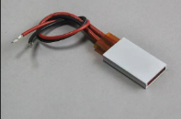 | 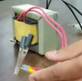 | 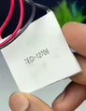 | 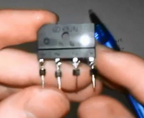 | 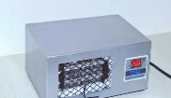 | 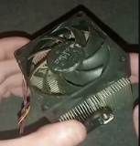 | 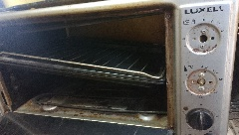
Name | PTC Aluminum Heater Plate | Electric Transformers 12V & 16 V | Thermoelectric Cooler | RECTIFIER BRIDGE | Home AC unit Thermostat | PC Heatsink and Fan | Old Oven Frame
Quantity | 2 pieces | 2 pieces (  16 V 10 A, and 12 V 1 A) | 1 piece | 2 pieces | 1 piece | 1 piece | 1 piece
Description | a heating element of the convection system of the prototype | Turns the unstable alternating current found in households into usable DC. | A cooling element of the convection system of the prototype | Turns the Alternating (AC) current into direct current (DC) | To control the temperature of the prototype | Used for heating and cooling in the convection system of the prototype | The frame of the prototype
Picture |  | 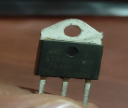 | 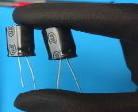 | 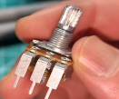 |  |  | 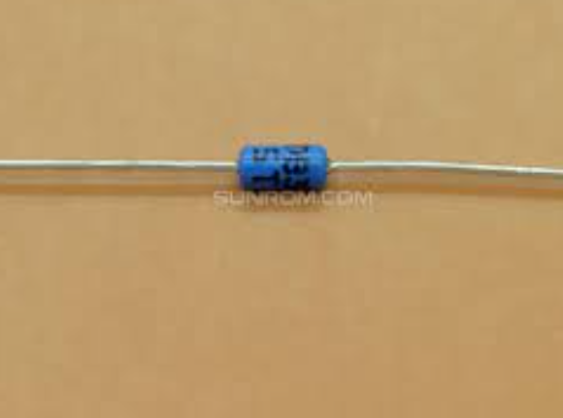
Name | Recycled acrylic | Triac bt136 | Capacitors | Potentiometer | Wires | silicon diodes | Diac db3
Quantity | 1 Pieces | 1 piece | 2 pieces (4500 micro  50 volts, and 470 micro  25 volts) | 2 pieces | From 1 to 1.5 m | 2 pieces | 1 piece
Description | To make the side of the frame | Used in the dimmer circuit to control the light intensity | Softens Direct Current (DC) coming out of the rectifier bridges | Two potentiometers one with 5 kilo ohms and other with 1 mega ohm | A copper wire to connect the circuit | Used for setting the speed of the fan for the heating and the cooling system separately | Used in the dimmer circuit to control the light intensity

The methods
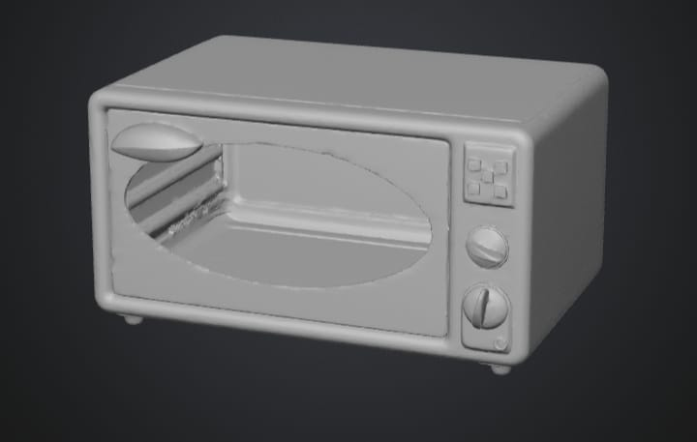
- For the sake of constructing a successful prototype, a 3D design was prepared first to visualize the prototype’s shape, which is shown in Figure 1.
- Disassembled the oven frame, exposed the fiber glass, extracted the fiber glass insulation layer from the oven, and Extracted the PTC heaters and rotary switches of the oven.
Figure 1 3D Design
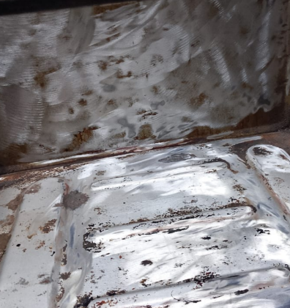
- Removed non-essential components remaining in the oven, cleaned the empty frame of the oven of left over residue as shown in Figure 2.
- Extracted the power supply from the PC to extract the capacitor, wires and the variable resistance.
- Extracted the rectifier bridge, a capacitor, and the acrylic from the mini fridge.
Figure 2 Prototype Residue Extraction
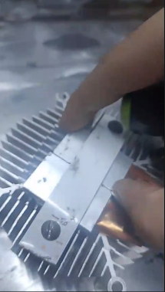
- The Thermostat was extracted from a home AC unit, and the transformer 16V 10A was extracted from the oven while the 12V 1A transformer was extracted from an old radio.
- Connected the transformer with the capacitor and the bridge to soften the direct current, put the heat sink in the oven, and the fan.
Figure 3 Heat Plate Placement
- Put the heater plates on the side of heat sink, as shown in Figure 3, and the thermoelectric on the back of the oven. Connected the thermostat to the prototype panel and connected silicon diodes on the PTC and thermoelectric cooler wires to the fan to adjust fan speed using variable resistance.
- Soldered a dimmer circuit from a capacitor, triac, diac, resistor, and variable resistance to control the light intensity, and connected it to an old potentiometer cap from the oven.
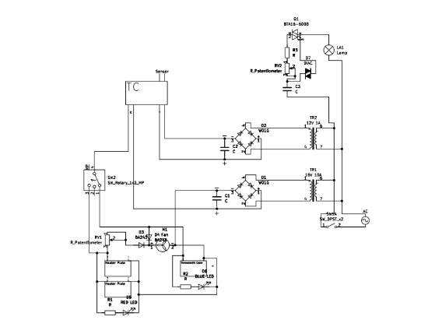
- Established a joint connection between one side of all components, connected the remaining sides to an old rotary switch from the oven.
- Connected the PTC and thermoelectric wires to the relay of the thermostat.
- Connected the heat circuit to the transformer output.
- Completed the final connections of the circuit as shown in the schematic in Figure 4.
Figure 4 MultiCubator Circuit Diagram

Test Plan:
A test plan ensuring the solution is both working properly and meeting the design requirements consisted of the following:
- Using a voltameter, the voltage of the electric current at the point of the PTC heaters and the TEC cooler is measured, ensuring the functionality of the transformer.
- The temperature in the incubator was measured by putting a thermometer inside it for 5 minutes, ensuring the calibration validity of the heat controller thermostat.
- A digital thermometer is installed on the top of the incubator’s frame, ensuring the quality of the insulation.
- An E. coli bacteria sample is prepared and placed inside the incubator for 6 hours, testing the growth rate.

Results:
Negative results:
- While disassembling the conventional oven, the frame almost broke due to trying to unscrew it from the wrong side. It was then reassembled, and the legs were properly removed first.
- When the voltage was measured, it was found that the transformer’s capacity was not enough for the PTC requirements, so multiple other transistors were used until one worked.
- During the calibration test, it was found that the calibration was off by 0.9°C, then 0.4°C. the thermostat was recalibrated until it matched the real temperature.
Positive results:
- The voltage of the current was exactly 12V, matching the PTC heaters.
- The thermostat calibration matched the thermometer’s readings perfectly.
- The digital thermostat measured no change in temperature outside of the incubator, indicating that the insulation is working.
- The measured growth of the E.coli bacteria sample showed exponential growth, which is presented in table 1 and Figure 5.
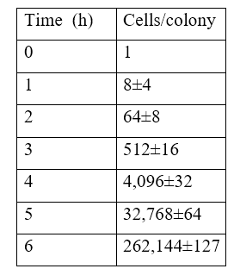
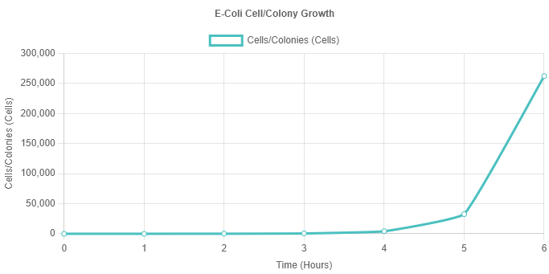
Figure 5 E-Coli Cell/Colony Growth
Table 1: Cell/Colony Growth

The Analysis
Binary fission formula

The binary fission formula, mathematically called the exponential growth equation, is the formula used for calculating the number of cells in a colony of bacteria after a certain number of generations or binary fission that happened over an interval of time as represented by the following figure. Usually, after just a couple of hours, it becomes impossible to count the cells with just a microscope, so this formula is the main way to calculate the growth of bacteria in low-end laboratories.
$$N_{t}= N_{0} ×{(2)}^{n}$$
The $N_{t}$ is the number of cells after a given amount of time, $N_{0}$ is the number of the original cells at time 0, and the $n$ is the number of generations, which is the number of times the cells have undergone the process of binary fission in the studied time period. The number of times the cells divide per hour varies depending on the type of bacteria and the temperature at which they’re incubated. In order to calculate the growth of the bacteria, the $n$ of our bacteria, which is E. coli, should be calculated first. By solving for $n, n=\frac{\log{(N_{t})}-\log{{(N}_{0})}}{\log{(2)}}$. Starting with one strain of E. coli bacteria, $N_{0}$ is equal to only 1 cell. The sample is then incubated for 1 hour at 37 °C. After incubation, the sample is observed under the microscope with 400x magnification. It is found that there are 8 cells in the sample, meaning that $N_{t}$ is equal to 8 cells. Substituting in the formula, $n=3$, meaning the cells have divided 3 times, 1 per 20 minutes. Using the original formula, we can determine how many cells per micro-colony will be present after 6 hours of incubation, which is found to be ~262,144 cells per micro-colony.

Turns ratio equation
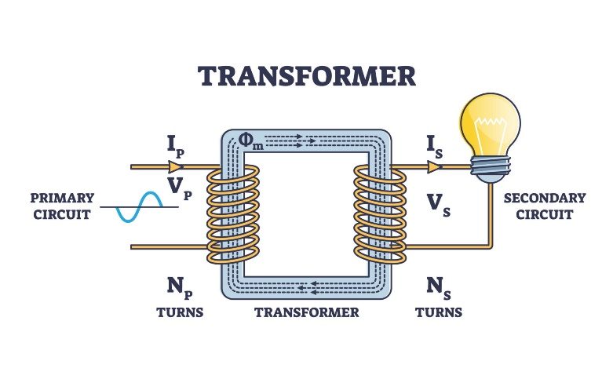
The turns ratio equation is the relation between the number of turns revolving around each side of an electrical transformer and the voltage of the current before and after the transformation, as shown in the figure. This equation is primarily used to determine the ratio between the turns in a transformer in order to produce the desired Voltage and Amperage for the circuit.
$$\frac{N_{p}}{N_{s}}=\frac{V_{p}}{V_{s}}$$
In an electrical transformer, the circuit is connected by wrapping the wires around an iron core, creating a magnetic field, where the other side of the wires receives the charge through the magnetic field. The ratio between the number of turns determines how much voltage is produced in the circuit. In the equation, N$p$ is the number of turns in the wire at the side of the power source (the wall outlet), while N$s$ is the number of turns at the other side. The V$p$ is the voltage produced by the power source, and V$s$ is the voltage produced by the transformer. In the incubator, two transformers are needed, one for the thermostat and one for the heater/cooler. The wall outlet produces a voltage of 220V, while the required voltage for the heater/cooler is only 12V. Using the equation, the ratio between the turns needs to be 220/16, which means that for each turn at the heater/cooler’s side, 14 turns are needed at the power source side. For the thermostat’s transformer, the ratio is 220/12, needing 18 turns at one side of the power source for each one of the other side. Overall, the transformers produce 16V 10A for the heater/cooler, and 12V 1A for the thermostat
The Peltier law equation
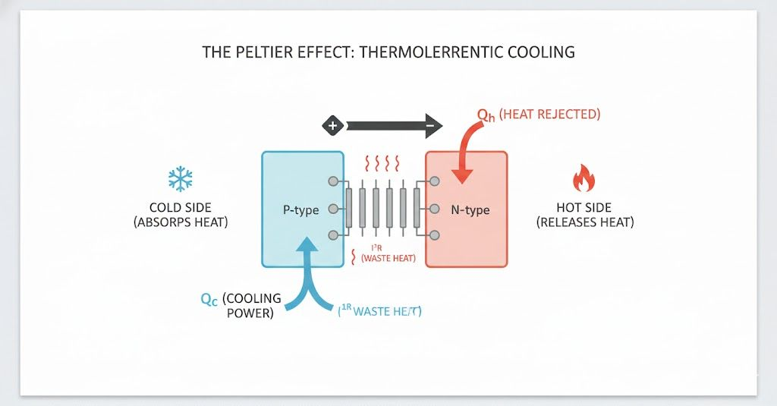
Standard incubators turn on the heater until the incubator reaches the desired temperature, and when the temperature exceeds the limit, the heater just turns off and waits for the room to lower the temperature. When the room's temperature is higher than the desired temperature, it becomes impossible for the incubator to function, killing the cells. to add a cooling system to the incubator, the Peltier effect is required. The Peltier effect law shown in figure 8 equation is used to determine the required current intensity in order to reach certain temperatures. The law states that
𝑄=𝜋×𝐼×𝑡
Where Q is the heat energy that is absorbed after the current is applied, π is the Peltier coefficient, which depends on the material that is used as the Peltier, I is the current intensity passing through the Peltier, which is measured in Ampere, and finally, t is the amount of time the current is passing through the Peltier, where increasing the time would increase the absorbed heat energy simultaneously, since the Peltier continues to absorb the heat energy over time. However, to keep in mind that the electricity passing through the Peltier also creates waste heat, which is calculated by the Joule penalty law: $Q_{waste}=I^{2}×R$, and if Q waste becomes higher than the absorbed heat, Peltier stops cooling. We needed to know the current intensity required to absorb 24,000J, which is equivalent to 15 °C, in only 16 minutes. Solving for I and considering the Joule penalty, it is found that the required current is 10A.
The First Law of Thermodynamics is the universe’s ultimate accountant. The law of Conservation of Energy applies in thermal systems. The simple statement of the law is that energy cannot be created or destroyed; it can only change forms. For example, the heat in an incubator is not created, but is a conversion of electricity into heat. The formula for the law is: ΔU = Q – W, where (ΔU) is the change in internal energy, (Q) is the heat added to the system, and (W) is the work done by the system. The electricity is first converted into heat by the thermostats, then transferred to the air. Since the chamber is a rigid box, the air cannot push through the walls; hence, the work done is equal to zero. This caused the air molecules to move and collide faster, resulting in storing the heat in the air and transferring it to the bacterial sample. If the heater runs for 10 minutes, let the power generation rate be 160 J/s, and the time be 600 seconds, meaning that the energy added to the system is equal to 96,000 J throughout the 10 minutes. and the change in internal energy which is calculated using the Peltier effect, is equal to 24,000J. According to the first law of thermodynamics, the work done, which is the leakage of energy in the system is = 96,000 - 24,000 = 72,000J. Since the time is 600s, this means that the power leakage is about 120J/s.
The table of learning outcomes
Subject | Learning outcome | Key concept | Usage
Maths | Math.2.03 | The Permutations | To calculate the uncertainty in the growth of bacteria
Maths | Math.2.01 | Polynomial functions | To draw the data and expect the results and the range of a specific data set
biology | BIO.2.01 | The GMO | Helped us know how the genetic material of different organisms affects their preferred habitats
Physics | PH.2.03
  Dynamic electricity
  To know the required conditions for the continuous flow of electric charge in the circuit.
Physics | PH.2.05 | Capacitor charging and discharging | To study the capacitors to use them to soften the circuit

The Conclusion
The problem chosen to be solved for this project was to turn electronic waste into a beneficial device able to serve in school laboratories. The selected solution was to construct a bacteriological incubator, as it has the potential to utilize multiple different wasted electronic parts and make a real difference in the school’s biology lab. The device was made of a heating system, a cooling system, and an old oven functioning as the shell of the prototype. Regardless of the negative results, the prototype has successfully met all the major design requirements of performing at least two functions (generating heat and controlling light intensity), and providing at least one measurement (the internal chamber’s temperature). Moreover, the device was able to overcome the high initial price problem present in the two previous solutions, the VEVOR 20L lab incubator and the Thermo Scientific Heratherm IGS180. By reviewing and benefiting from other solutions, the device has successfully increased the research capabilities in school labs, besides turning e-waste into something beneficial.

Recommendations
1.Humidity control system
It is highly recommended to add a humidity control system to the device due to its ability to measure humidity levels in the chamber and make adjustments as needed. Modifying the incubator to utilize this system would enable it to preserve the agar from evaporating for a longer duration, allowing for longer research periods without needing to replace the agar plates frequently. However, implementing this suggestion is challenging due to safety concerns and material scarcity. Humidity sensors are extremely rare to find in older devices, and even if they can be acquired, they pose potential safety risks. Humidity control systems require a strong sealing mechanism to minimize moisture exposure near heating elements and electronics. Otherwise, water could damage the circuitry and potentially pose a hazard to users. A final concern to address is accuracy. Constructing a humidity system using scavenged materials while maintaining an error percentage within ±5% would be an extremely challenging task.

CO2 injection system:
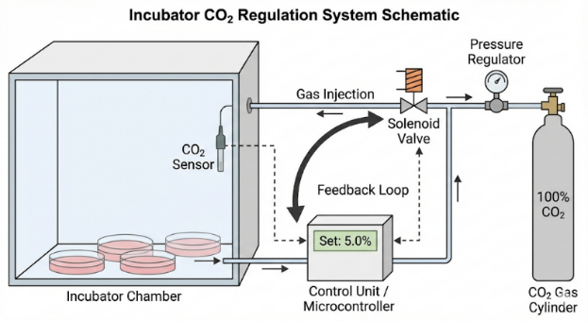
An important addition to be recommended for the incubator is a CO2 injection system. This is because most of the culture media contain sodium bicarbonate, which is a base. The CO2 reacts with the water, which forms carbonic acid. This neutralizes the media. Otherwise, the system would lose acidity, and the cells would eventually die in the long term. The CO2 injection system consists of an IR sensor that detects the CO2 levels in the incubator, and when it drops below 5%, it opens a solenoid valve that’s connected to a CO2 gas cylinder, puffing the gas into the incubator. This system is presented in Figure 6. We unfortunately couldn’t apply such a system in our prototype, since, without a license, we are not allowed to have a CO2 container for safety reasons.
Figure 6 CO2 Injection System

Water jacket insulation system:
The most important section in the incubator is the insulation system, since poor insulation would lead to huge amounts of heat losses, which would put the heaters under a higher load just to reach the desired temperature. For instance, if the heaters worked regularly, they would need to be active every 3 minutes; poor insulation would drastically increase that to once every minute. This also has a higher risk of killing the cells, since if the walls get too cold, water droplets will start to build up on the walls and the ceiling, and if a droplet falls on the petri dish, this instantly contaminates and kills the cells. We can use the water jacket insulation system to insulate the incubator, which works by double-layering the walls and pouring warm water in between. Water has high heat capacity, which is why it’s a good insulator, and it also matches our requirement of the project being environmentally friendly. We instead used passive foam, since the water jacket requires stainless steel, which is hard to find in old devices.

Stainless steel & copper lining:
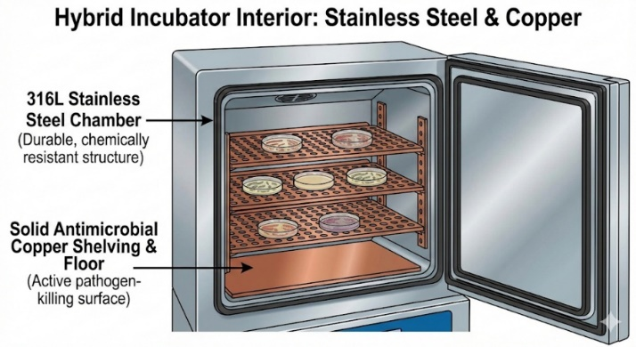
It’s recommended to double-layer the body of the incubator, where it’s best to use stainless steel for the outer shell, which has high chemical resistance, preventing rusting. However, for the inner chamber and racks, it’s recommended to use copper lining as the main material, as shown in figure 7. Biofilm has a high risk of cross-contamination between the bacteria, where the bacteria produce an extracellular matrix that sticks to surfaces, and rough surfaces like wood or plastic are easier to stick to. To prevent biofilm, the best way is to use copper lining. This totally prevents any leakage of bacteria outside the petri dish. That’s because copper lining is oligodynamic, which means that it instantly kills any bacteria that touch it. This is crucial, since the one thing that shouldn’t happen in a laboratory is contamination in/outside the incubators, which can cause catastrophic disease spreads. This wasn’t applied in the prototype because copper lining costs too much, reaching 11 USD per kg.
Figure 7 Steel & Copper Lining

The literature cited
Monod, J. (1949). The growth of bacterial cultures. Annual Review of Microbiology, 3(1), 371–394. https://doi.org/10.1146/annurev.mi.03.100149.002103
McLyman, C. W. T. (2011). Transformer and inductor design handbook (4th ed.). CRC Press.
Eagle, H. (1971). Buffer combinations for mammalian cell culture. Science, 174(4008), 500–503. https://doi.org/10.1126/science.174.4008.500
Freshney, R. I. (2016). Culture of animal cells: A manual of basic technique and specialized applications (7th ed.). Wiley Blackwell.
Grass, G., Rensing, C., & Solioz, M. (2011). Metallic copper as an antimicrobial surface. Applied and Environmental Microbiology, 77(5), 1541–1547. https://doi.org/10.1128/AEM.02766-10

The Acknowledgement
We want to especially thank Prof. Ghadir El-Housseiny (Associate Professor of Microbiology and Immunology-Pharmacy--ASU) for providing us with an E.coli sample, and Dr. Dalia Hammad (our biology teacher) and the school’s biology lab for supervising our test plan. Finally, we can’t forget Mr. Mohammed Bekheet (capstone head), Ms. Ninette Refaat (capstone leader), and Mr. Mohammed Zaki (Capstone teacher) for supporting us through the whole capstone.

